Event Data

This Is the base data, we need to set: 一張卡片編號

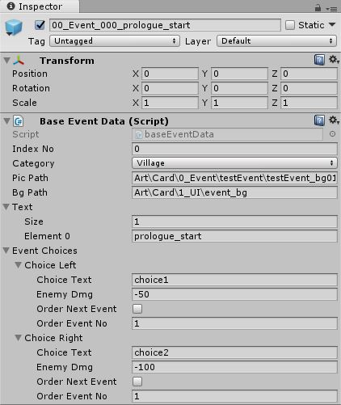indexNo : Event ID(unique, cannot repeat) 卡片總編號

category : Event Category, for event random ,but it don’t work now 故事編號

picPath : pic for Event 正面圖片

bgPath :pic for Card Back 背面圖片

text : text for this event 文字

eventChoices(Left&Right)

now, only damage is working,

and need to put the value of index no. under the‘order next event’, if not the value of orderEventNo will set to default value to 0.

How to create new Event

1. create GameObj
2. add Component “BaseEventData” to GameObj
3. make the GameObj to Prefab(drop&drag to Project floder)
4. See the EventManager Prefab
5. Add event to EventDataObject(Add size and Drag new Prefab in here, don’t need care about sequence)
6. Compele ,try to plat the game!

1. create GameObj

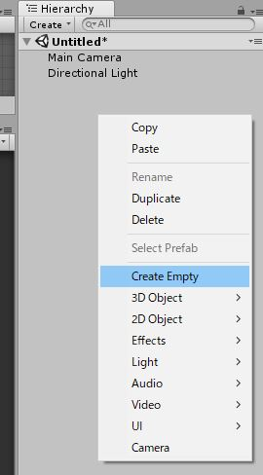click mouse right at Hierarchy, and Create Empty.

2.add Component “BaseEventData” to GameObj

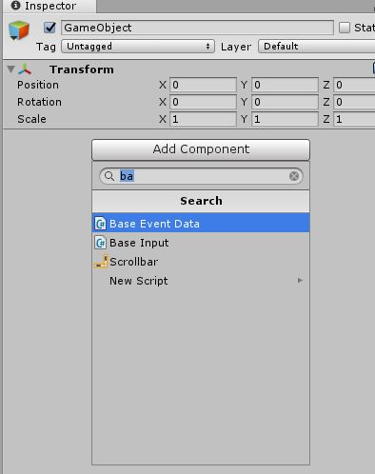see the Inspector with the new GameObject.

And click mouse right to add component.

Type’base event data’and choise it

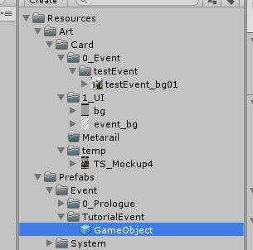3.make the GameObj to Prefab(drop&drag to Project floder)

Drag the GameObj from Hierarchy to Project Folder

(Resources/Prefabs/Event)

4.See the EventManager Prefab

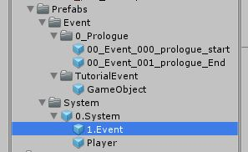choice 0.System and pulldown it,

then click 1.Event

5. Add event to EventDataObject

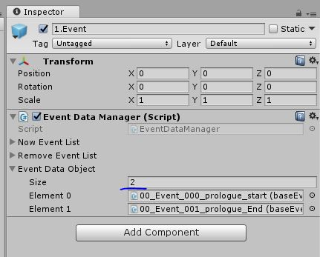

see the Inspector , click EventDataObject ,

add size and drag the new Event prefab to here;

don’t need care about sequence)

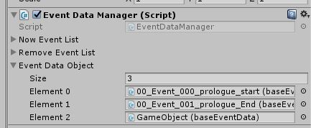

Compelet!